Deepseek Price Research
Ryan Godburn

API Access:
Cache Miss Scenario –
$0.55 / million input tokens (cache miss) + $2.19 / million output tokens = $2.74 max per prompt
Cache Hit Scenario –
$0.14 / million input tokens (cache hit) + $2.19 / million output tokens = $2.33 max per prompt
https://api-docs.deepseek.com/news/news250120

Local Access:
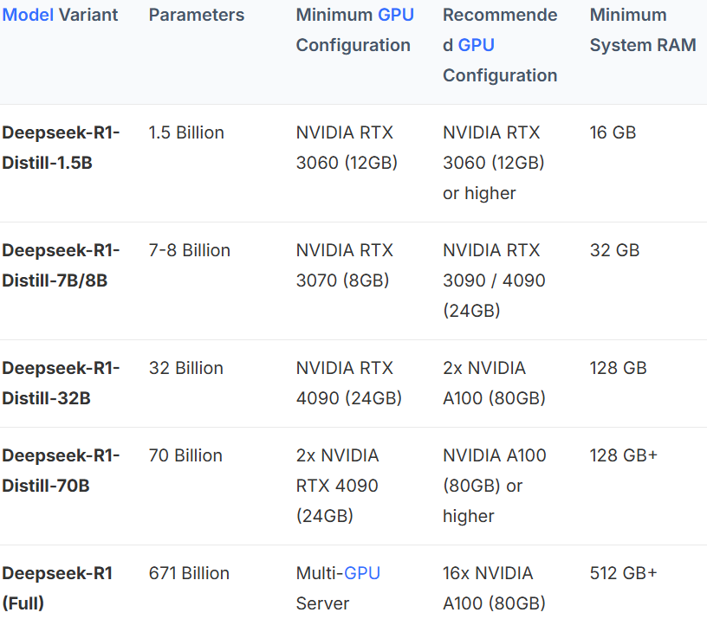
70B: A100 SXM – 80 GB VRAM – 125 GB RAM – 16 vCPUs - $ 1.39 /hr
https://www.runpod.io/product/cloud-gpus
https://www.byteplus.com/en/topic/553200?title=deepseek-r1-hardware-requirements-size-gb-and-system-guide

